- \Operation\Carton transfer\Carton reaction
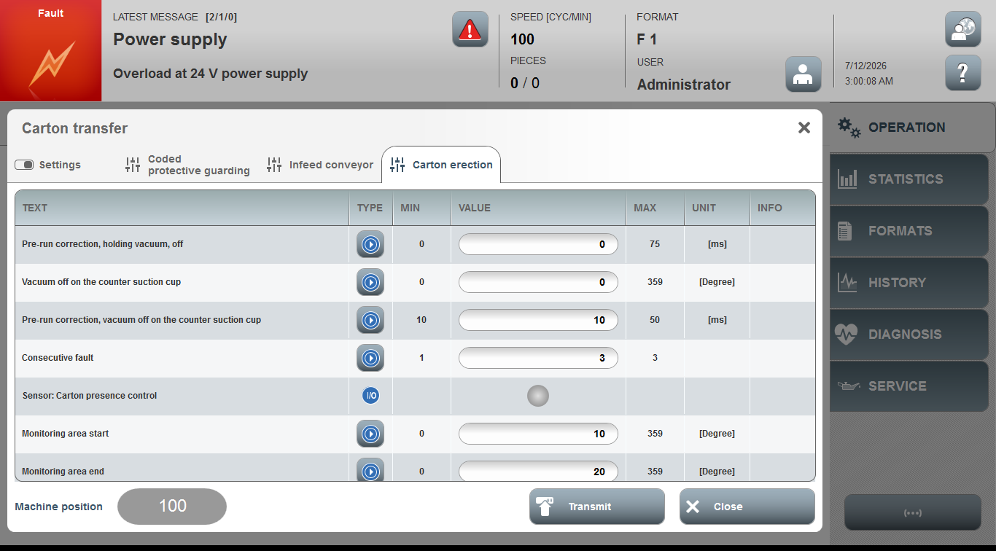

Acceptance criterion | Limits | Pass / Fail: Dev-No. | Date | Initials
Screen matches screenshot | N / A
Holding vacuum, off | 150 … 290
Pre-run correction, holding vacuum, off | 0 … 75
Vacuum off on the counter suction cup | 0 … 359
Pre-run correction, vacuum off on the counter suction cup | 10 … 50
Consecutive fault | 1 … 3
Monitoring area start | 0 … 359
Monitoring area end | 0 … 359

